



Solution Design Document

SmartForm

Version1.0

**February 25, 2019**

Document History

|  |  |  |  |  |
| --- | --- | --- | --- | --- |
| Revision | Description | Date | Prepared By | Reviewed By |
| 1 | Solution Design Document – Draft Version | 23/02/2019 | Siva |  |

Table of Contents

1 Introduction 4

1.1 Document Purpose 4

1.2 In Scope 4

1.3 Out of Scope 4

1.4 Relevant Documents (Current Situation/Environment) 5

1.5 Assumptions 5

2 Systems Overview 6

2.1 Applications and Systems 6

Type of access required – SSO, credentials etc. 6

2.2 Applications Interfacing 6

3 Analysis 7

3.1 High-level components 7

3.2 Narrative Use Case and Detailed Process 7

3.3 Requirements 8

4 Solution Overview 10

4.1. Solution Diagram 10

5 Data Structure ER Diagram 14

5.1. Data Structure 14

6 Pseudo Code for Transactions 14

7 Inputs and Outputs 14

7.1. Inputs 14

7.2. Outputs 14

8 Assets 14

9 Robot Schedule 14

10 Workflow Modules 14

SmartForm Workflow 14

a. Exceptions 15

11 Logs 16

12 Reusable Components: 16

13 Coding Standards 16

14 Frequency – Put in Scheduling section 16

15 SLA- Put in Scheduling section 16

16 Report Generation 17

# Introduction

This document will provide solution and technical design of Data Management - SmartForms.

## Document Purpose

The purpose of this document is to explain the technical design and overview of SmartForms implementation for the Data management.

Its main purpose is to –

* Provide the link between the functional specification and the detailed technical design documents
* Detailed functionality provided by each component or group of components and show how the various components interact in the design
* Provide a basis for SmartForms detailed design and development
* This document is not intended to address installation and configuration details of the actual implementation. Installation and configuration details are provided in technology guides produced during project

As is true with any high-level design, this document will be updated and refined based on changing requirements.

## Distribution List

|  |  |  |
| --- | --- | --- |
| Name | Role | Notes |
| Orla Weare - Business  Ashok Verma – Technology | Project Owner | Overall project owner and Level 1,2 escalation |
| Abhinav Sharma | Business Analyst | Point of contact for process related queries |
| Nitin Agarwal- DM Smart Form  Ewa Ziemkowska- Smart Form | Business PM | Point of contact for process related queries |
| Gary Tessler and Malissa Ford | Tech Solutions PM | Point of contact for process related delivery |
| KJ Davis | Tech Solutions | Point of contact for process related delivery |
| Mohan Patil | PM | Point of contact for process related delivery |
| Siva Audina | Tech Architect | Point of contact for process related delivery |

## In Scope

* All transaction for Data management which includes Personal and Job changes
* Self-Service: Personal transactions and specified 5 job transactions

Providing links to PeopleSoft

* Non-Self-service:

Individual: User updates the details without approval

User updates the details with approvals

Bulk upload: User Uploads data by importing XL Sheet

Happy Path:

Below request are eligible for self service

* Request with valid data and no approvals needed

Below request are eligible for automation

* Individual and Bulk data request with valid data and with provided approvals

Exceptional Flows:

*Requests in the automation queue can be moved to Remedy (Ticketing tool)

* 1. Out of scope
* Request with no valid data
* Requests with pending approvals

* 1. Relevant Documents (Current Situation/Environment)

Table with names

* 1. Assumptions
* Employee data is accurate in people portal at the time its fed onto Smart form
* There is a regular feed (need to decide frequency) from people portal to Smart form.
* Associate data will be managed in PeopleSoft. Export of data will follow existing global standard processes unless otherwise specified in the requirements
* If a population group is not listed in the requirement, that population group is not applicable/out of scope.

1. Systems Overview­­

This Section depicts the Application/System being used in current process and what Application/System will be used after automation implementation.

* 1. Applications and Systems

|  |  |
| --- | --- |
| Applications | URL *(if any)* |
| SmartForms | Alpha:  Beta:  Gymea:  Delta: |
| PeopleSoft | Alpha:  Beta:  Gymea:  Delta: |

Type of access required – SSO, credentials etc.

* 1. Applications Interfacing

|  |  |
| --- | --- |
| Applications/Systems | Interfacing mechanism |
| SmartForms | Through SmartForms UI |
| PeopleSoft |
| Remedy TT |

# Analysis

## High-level components



* 1. Narrative Use Case and Detailed Process

|  |  |
| --- | --- |
| Use Case Name | Data Management - SmartForms |
| Goal in Context | Smart Form is a dynamic web-based form solution used to collect, navigate, validate and to eliminate manual work, defects with automation |
| Pre-conditions | User entered data should be valid and must fulfill the requirement of automation |
| Success End Condition | People soft will be updated with user entered data either through self-service or automation |
| Primary Actor | SmartForm, RPA and PeopleSoft |

* 1. Requirements

GUI / SCREEN DESIGN FOR WEB APPLICATIONS:

| GUI Aspects | Considerations / Alternatives | Details and (optional) Rationale |
| --- | --- | --- |
| Usage of Frames | Yes / No |  |
| Usage of Style sheets (CSS) | Yes |  |
| Sitemap | No |  |
| Menu organization and Navigation | Top Menu |  |
| Technologies | HTML5, CSS3, Angular6, Bootstrap4 and NodeJs |  |
| Colour Scheme | Single scheme for all pages |  |
| Images and their size and quality | PNG / JPEG  Size |  |
| Max page size | Kbs |  |
| Usage of Page ID apart from Page title | Not required |  |
| Screen Resolution | 1366x768, 800 x 600, 1024 x 768, 1024×576, 1152×648, 1280×720, 1366×768, 1600×900, 1920×1080 |  |
| Browser support | IE 10+, Chrome, Firefox, Safari |  |
| Validation | Common validation / Individual validation |  |
| Error message display locations | TBD |  |
| Search Facility and Technology | NA |  |
| Support for search engines | NA |  |

Services DESIGN FOR WEB APPLICATIONS:

| GUI Aspects | Considerations / Alternatives | Details and (optional) Rationale |
| --- | --- | --- |
| Technologies | Java 1.8, Spring 5+  Hibernate 4.0  MySQL 7.0 |  |
| Validation | Common validation / Business Rules validation |  |
| Error message | TBD |  |
| Search Facility and Technology | NA |  |
| Support for search engines | NA |  |

CODING UI:

| Code Element | Considerations / Alternatives | Details and (optional) Rationale |
| --- | --- | --- |
| Documentation | Angular.io |  |
| HTTP Method | GET, POST |  |
| Common Header & Footer and Includes | Yes |  |
| Session Cleaning |  |  |
| Database Connection |  |  |
| Screen Validations | Date, Trim, Maxsize, Browser Compatibility, Format, Field type |  |
| Security | Restricting intermediate URL access for valid & invalid users |  |
| Folder/ Package Structure | Yes |  |

CODING Services:

| Code Element | Considerations / Alternatives | Details and (optional) Rationale |
| --- | --- | --- |
| Documentation | Java Docs |  |
| HTTP Method | GET, POST |  |
| Session Cleaning |  |  |
| Database Connection |  |  |
| Security | Restricting intermediate URL access for valid & invalid users |  |
| Folder/ Package Structure | Yes |  |
|  |  |  |

*Final Solution design will be ready once the clarification is received.

# Solution Overview

## 4.1. Solution Diagram

1. Smart Form Solution Flow

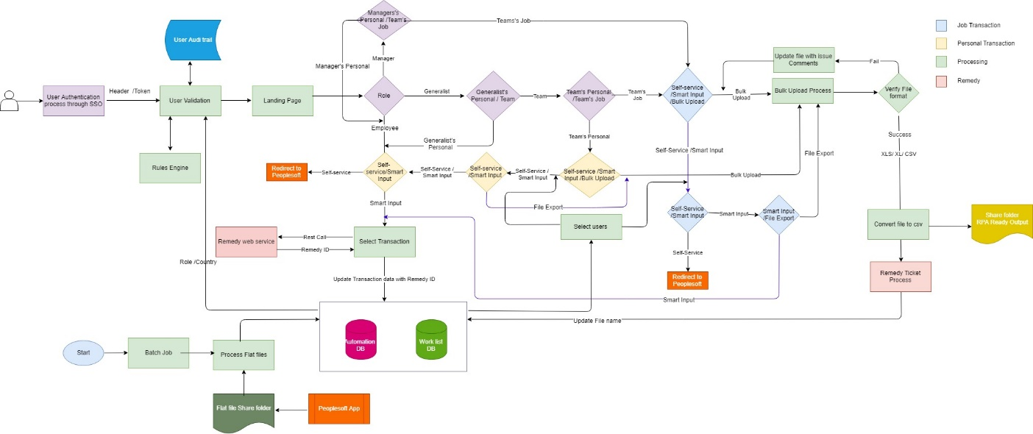

Figure 1 Smart Form Solution Flow Diagram

* User choose smart form action from other portal and SSO helps user to login in smart form portal
* User will land on landing page and based on his/her role and country/region applicable transactions and fields will be visible to him/her
* There are two types of transaction categories one is personal transactions and second one is Job transactions
* Transactions are further divided into Self Service, Non-Self-Service and Bulk Upload
* For self-service transactions, user will get redirected people portal
* For non-self-service transactions, user will provide input (smart input or form data) from smart form. Ticket will get created in ‘Remedy’ and ticket id will get updated in ‘Worklist DB’ and new entry will get created in transaction table with worklist Id.
* For bulk upload, user can upload .CSV, .xlsx, .xls. Files uploaded for bulk upload transactions
* Employee can only change his/her personal details. Manager can change his/her own personal details and others job details, but manager is not allowed to change others personal details. Generalist can do personal as well as job details changes for others.
* System should continuously synch every 2 hours automated data with people soft data by running batch jobs.

1. Data management service
2. UI Solution

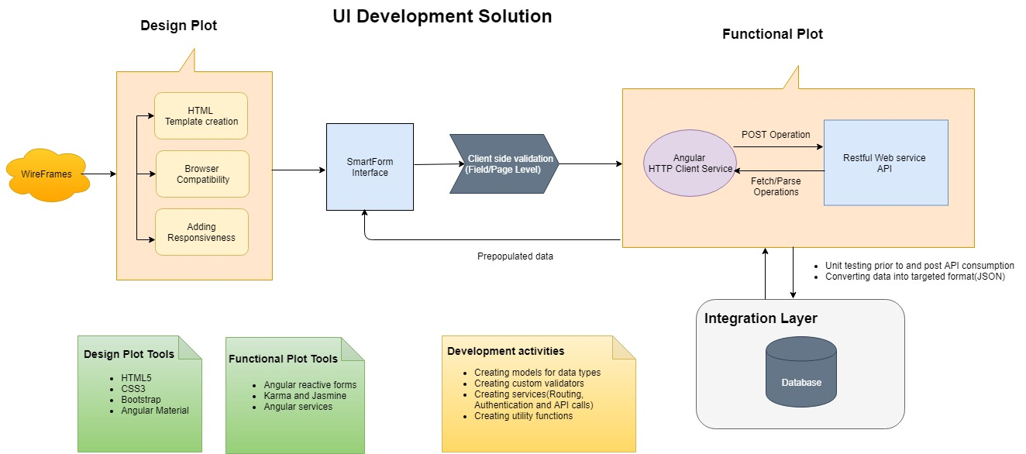

Figure 2 UI Flow Diagram

* Creation of HTML templates as per provided wireframes using HTML5 and CSS3.
* Ensuring the application is compatible with all browsers.
* Adding Responsiveness to render the application properly in devices with different screen sizes. Latest version of Bootstrap will be used to do so.
* Building Application with all angular features such as components, directives, services, interfaces.
* Using Reactive forms (angular approach) for building forms which uses an explicit and immutable approach to manage the state of a form at any point of time.
* Performing Field and page level validations which includes field type, format and business validations.
* Enabling and disabling transactions based on Role and Country of an employee
* Making use of advanced angular feature, HTTP Client service, to fetch and post data in required format (CRUD operations) through Integration API.
* Unit testing for each construct of the application using Karma and Jasmine.

1. Batch Service

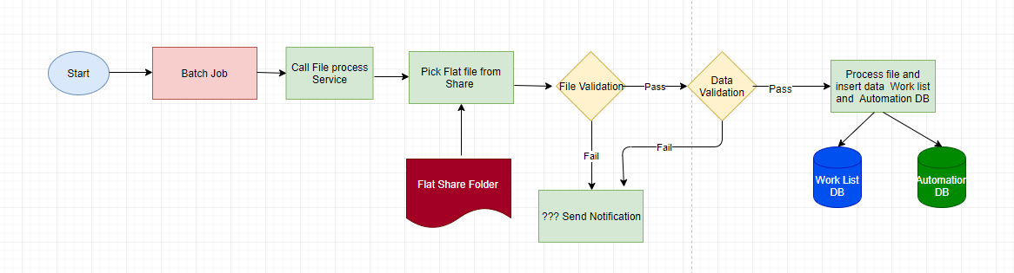

Figure 3 Integration: Batch Service

* Batch service is responsible for synching master data with people soft data.
* PeopleSoft will push flat files into shared drive
* Batch job services will pick those flat file/s and validate it first
* System will first do the file validation and then data validation (validation exception part is an open question)
* After validation entry will be made in worklist table and all data will get inserted into master table

1. Bulk Upload

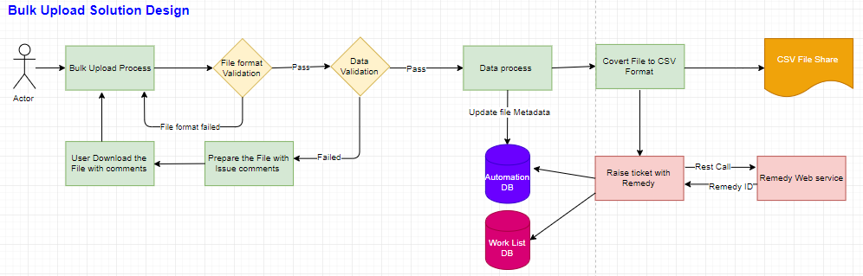

* Bulk upload is the functionality to perform single or multiple transactions for multiple employees.
* Requestee can upload either .csv, .xls or .xlsx files and that file can contain record for single transaction or multiple transaction.
* User can upload file of any size but internally Integration system will have to convert it into files of size max 400 kb.
* System will first validate the file data and if even a single record is invalid then system will add comment for invalid record and make file available for user to download. User can then make correction into data and re-upload file for bulk upload
* Ticket will be created in Remedy and respective entry will be made in Worklist DB and file will get uploaded into shared drive and its path will get stored into Automation table

1. Remedy service

TBD

1. Notification service

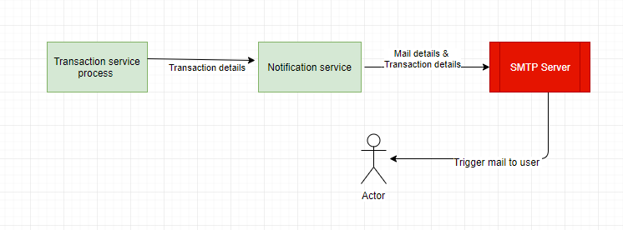

* Transaction service is responsible for sending notifications to requester or to approver
* Transaction service process provides transaction details to notification service and notification will be send using SMTP server by passing mailing details and transaction details

1. Configuration service

TBD

# Data Structure ER Diagram

## 5.1. Data Structure



# Input Processing and Output

# Input

* User entered data either Individual or Bulk data through Smart Form



# Processing



# Output

* User request can be self-service or automated through RPA and data will be updated to PeopleSoft

# API

* API to consume and to perform CRUD operations on PeopleSoft user data

# Robot Schedule

NA

# Workflow Modules

## SmartForm Workflow

* Employee land on Smart Form page
* Page is pre-populated with requestor indicative detail and probing navigation
* Is this about you or someone else
* Individual Vs Bulk Request
* Is this about transaction for which smart input can taken
* Employee write data in form which will create a worklist or Excel o/p
* RPA ready o/p
* Validated o/p for ticketing
* Validation of transaction. Can this be done without Remedy Ticketing
* Pure Redirect to (TT)
* Pure Redirect to Self- Service
* Fake self Service
* RPA ready o/p
* Validation of request and attachment.
* Convert the bulk request into a worklist or Excel
* RPA ready o/p
* Escape Valve

## Exceptions

|  |  |
| --- | --- |
| Exception | Description |
| Application Exception | Peoplesoft / Salesforce applications are down |
| Business Exception | Yet to receive from the Client |

# Logs

TBD

# Reusable Components:

* Wireframes
* Visual Designs
* HTML and CSS
* UI Common Components
* Common Services
  + Remedy Service
  + RPA Service
  + Notification Service
  + Work List Service
  + Rules Service
  + Read Flat File Service
  + Admin Service

# Coding Standards

* Maintain proper folder structure
* Divide the process into number of angular modules based on application type and functionality
* Avoid hardcoded delays
* Avoid defaults/ constants
* Configurable variables/properties can be used from Configuration file
* Proper naming conventions for variables and sequences
* Handle exceptions for all negative scenarios

# Frequency – Put in Scheduling section

* NA

# SLA- Put in Scheduling section

SLA is to verify all the applications received on the same day (TBC)

# Report Generation

# Share SQL queries to get below reports

1. Audit trail report (SMF): On this report we expect to see what action have taken in Smart form by requestor / user. Required a detail of transaction done, time spent, escape valve, escape valve reason etc.



1. Operation report (SMF): On this report we expect operational level detail on volume of transaction that are handled or generated out of Smart form. We can discuss more on if any other additional fields may be required to add here based on design.



1. Transaction Report: Capture detail of all transaction happens inside SMF



1. Ticketing detail report: It can be task report to capture all ticket or case id that come out of interaction with SMF.

